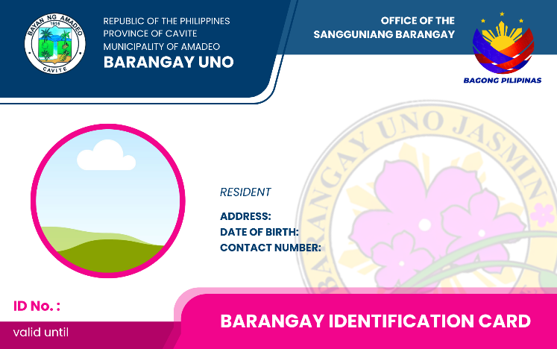
{{ validity }}
{{ photo }}
{{ cp_number }}
{{ cp_name }}
{{ id_num }}
{{ birthdate }}
{{ phone_number }}
{{ address }}
{{ last_name }}
{{ first_name }}, {{ middle_name }}

